2020 Onaway Speedway Mini Wedge Rules & Regulations
Rules may be changed / amended by Onaway Speedway, when deemed necessary.
Onaway Speedway Mini Wedge Mission:
To provide the safest racing program possible designed to teach young drivers 6-14 years of age the skill, sportsmanship and fair play needed to compete on and off the racetrack.
Vision:
Mini Wedge racing will be a great experience for both parent and child. Opportunities for continuous education and growth will foster personal and career growth. Our efforts will be recognized by others who view us as a benchmark for safety and fairness.
Values:
We must strive to provide a fun and safe environment for every person. We do believe all of our Drives desire to excel in their life. We must treat each other fairly with respect, plus offer encouragement and appreciation as we work together towards the same goals. To promote families spending good quality time together, at or away from the racetrack
Penalties: If found with modifications to the motor or the restrictor plates or clutch the first offense Disqualified for the night and loss of points second offense Disqualified for 2 race nights and loss of all points for the year Third will be suspended for 12 calendar months.
2020 Rules & Regulations:
Car Section 1
Engine Section 2
Race Rules Section 3
Driver Personal Safety Section 4
Body Drawlings / Specs Section 5
Point System Section 6
Race Procedure Section 7
Onaway Speedway encourages a fun, family atmosphere. Times may arise that are stressful and upsetting to both parents and the driver. When addressing these issues, please speak in a manner that is respectful not only to the driver, but to others that are within hearing distance.
Section 1 – Car
Wheelbase 45” – 49”. Maximum width of the outside of the tire is 45”. There are to be no roofs, sail panels.
A maximum of a 3-inch spoiler will be allowed. Spoiler side’s maximum height will be 3 inches from deck and 5 inches long.
Must have 4” number on rear of kart.
All karts must be constructed of steel tubing with a complete 6-point roll cage including adequate side protection. Cages must be a minimum of .065 x 1” steel tubing welded to the frame.
The engine must be located behind the driver’s seat.
No part of the engine can be located beside the seat.
Floor pans are required to be made of steel or minimum .040” aluminum. The floor pans are to be securely bolted or riveted to the frame. The length of the floor pan must go from the center of the seat to the front of the frame going past the driver’s pedals.
All karts must have a fully enclosed interior.
All karts must have a fully wedge Late Model appearing body no perforated, expanded metal body panels are allowed. No open fenders, vents or drilled holes in body will be allowed. There must be at least 4” of body behind the rear wheels.
There will be no covered or enclosed motors all motors will remain completely visible at all times. See Body Drawings for more information.
Tires must be a Hoosier 15600 "11 inches tall" FK Compound. No grooving or sipping of the tires. No treating or soaking of tires. Tires must durometer 50; any tire that durometer is 48 or less will be deemed has treated and will result in a 12-month suspension.
Rim width cannot be any wider than 6-1/2” wide and must be at least 6” Tall.
Axle must be a Steel Axle and a minimum of 3/16" Wall Thickness Max Length of 38”.
Both rear tires must be keyed to the axle no limited slip, ratcheting mechanisms or devises allowing tire slip allowed.
No suspension will be allowed. This includes springs, shocks, rubbers, torsion bars and any other type of dampening devise.
Rear deck height cannot exceed a maximum of 27.5” from the ground and a minimum of 22” high from the ground.
Rear quarter panel cannot exceed a maximum of 24” and a minimum of 20”.
Body must be constructed of .040” aluminum sheet metal. Plastic may be used for nose, fenders and trim.
Kart must weigh no less than 335 lbs. with driver after the race. When tracks split the class by age, they must split it by 6-9 and 10-14 years old. The 10-14 year old kids must weigh in no less than 375 lbs. with driver after the race. Track can choose to weigh in before or after the race.
We highly encourage the doors and quarter panels to be wider than the tires with at the bottom of the doors and quarters to help prevent “Wheel Hop”.
At least one vertical D door bar must be welded on each side of the driver running from the main rail to side crash bars for driver protection. See rear side view drawing for more details.
Front and rear bumpers must be mounted at all times. Front and rear bumpers must have at least a 6" tall hoop.
Front and rear down tubes are mandatory for driver’s protection.
All tubing on main roll cage must be at least .065” wall tubing.
Driver’s seat must be mounted in four locations (4-Bolts)
Two door numbers must be present with a minimum of 12”.
Must have two return springs on throttle system at all times.
Must have two kill switches one must be mounted on the top of the roll cage visible to officials.
Any weight mounted on the kart must be painted white with the drivers name and number on the weight. Weight must be mounted by at least a 3/8” grade 5 bolt. Any weight lost during an event may result of a two-week suspension.
5-Point harness system is mandatory. All harness must have a SFI Rated patch.
All drivers must wear arm restraints and be attached to the 5-point harness not steering shaft.
All karts must have two triangle type side window nets attached to the roll bar one on each side of the driver.
Section 2 – Engine
Green restrictor plate must be purchased from MWA or Onaway Speedway and serial number must stay with that driver.
Remote fuel tanks are allowed mounted within frame rails in engine compartment. If mounted behind rear axle it must have an extra bar in place for tank protection.
Only stock 6.5 HP (212cc) OHV Predator Engine will be allowed.
If the Restrictor Plate or Engine is altered in any way, can result of a 12-month suspension.
Engine must remain stock.
Fuel allowed is E85 and regular gasoline with E85 you can change the Jets.
NO Alcohol will be allowed.
You cannot alter the exhaust in anyway. Cover can be altered to fit the chain guard if needed no taking out the spark resistor for the exhaust.
You can change the spark plug.
You can disconnect the low oil sensor.
You can run an ARC Air Cleaner.
You cannot change jets.
NO RACING carburetor
MAX-Torque clutch is the only clutch that can be used and must remain stock and without alterations.
You can run 12, 13 or 14 tooth Clutches. (This is to help decrease our rear axle gear for more ground clearance.)
Engine claim is set to $125; anyone finishing the feature can claim any driver, claim must be made after the heat race prior to feature race. An Onaway Speedway official can also swap a motor at any time for a brand new engine, YOUR ENGINE WILL NOT BE RETURNED TO YOU! This claim is the engine and Carburetor that is on that motor. But not the Clutch, Chain Guard or Air Cleaner. Track official must inspect all claimed engines before use.
The mission is to provide children a safe and competitive series to teach them the fundamentals, sportsmanship and completeness needed to grow into the sport as a young adult. Please keep in mind the Engine / Clutch claim is to give every child the opportunity to compete without the worry of their family not being able to afford it or their family does not “cheat” enough to be competitive.
Section 3 – Race Rules
All drivers must be accompanied by a parent or legal guardian. Unless you are appointed his / her legal guardian, by law, you cannot sign a release form for them. Therefore they cannot race. Any exception to this rule cannot be made by an MWA official and must be brought before the track’s management or track’s insurance carrier for a decision.
All cars will be lined up according to their time trial time. Failure to time in before the lineup will result in the driver starting at the tail of the heat.
Arguing about scoring or judgment calls will not be tolerated. Confrontations / arguments with Onaway Speedway Officials, track officials or another parent can result in a minimal suspension of 2-weeks from Onaway Speedway track.
The scoring tower is off limits to drivers and anyone who is not a track staff member.
Any parent, driver, or member of any team involved in any type of confrontation with anyone at the track will result in a suspension of driver and parent or legal guardian for at least two weeks from all events.
There will be NO WARNINGS given out for bad behavior such as; throwing a fit on the racetrack or pit area, arguing with the track officials, scorers, flagman or track owner. No going to another pit to argue this includes driver, crew and anyone with a Mini Wedge.
Age limit is 6-14 years of age.
Section 4 – Driver Personal Safety
All drivers must wear an approved SFI – 1 certified or SFI13 – 2A/1 Fire Suit. SFI certification patch shall be required on fire suit.
A Full Face helmet will be mandatory at all events.
All drivers must wear a neck brace.
All drivers must wear arm restraints.
All drivers must wear a closed toe shoe.
All drivers must wear fireproof gloves at all events.
Section 5 – Body Drawling and Specs
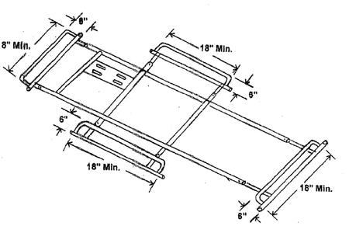

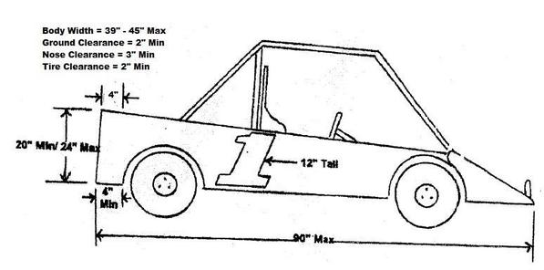
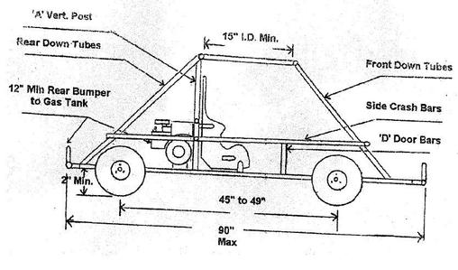
Section 6 – Point System
There must be at least three drivers racing to receive first place points. If there is not three drivers racing the first drivers will receive 4th place points and the second drive will receive 5th place points.
Drivers not in A Main feature will receive 10-Points.
Top-3 in points will receive awards at year-end.
Points will be counted for 6-9 year old drivers and for 10-14 year old drivers.
Only a driver’s highest Points race will be counted each week for events.
All ties will be broken by using the greatest number of 1st place finishes during the season. If a tie still exists, the number of 2nd, 3rd, etc. will be used in the same manner, until the tie is broken
Section 7 – Race Procedure
Cautions will be thrown when a driver spins out and is stopped on the track.
Caution will be thrown when a driver drives off the track and is stuck.
The caution car (judgement call) will be put to the tail.
Two cautions and the driver will be black flagged for that event.
The black flag will be thrown when a driver is driving rough; this is a judgement call and cannot be argued.
The class will be split into two classes 6 – 9 Year old and 10 – 14 Year old (restricted and non-restricted).
Race transponders will be mandatory.
Top three will receive a trophy at the end of the night in each class.
Top three must report to tech area.

